Test Project Module 2
(Editorial)
WSC2013_TP40_M2_actual_EN
Submitted by: Group 2

Arnold Sandjaja ID
Christoph Elmecker AT
Hee Min Sa KR
Hjortur Gudnason IS
Katsuji Hirata JP
Michel Bulon CA
Nuno Viana PT

محتويات

يتكون هذا الاختبار من الملفات التالية:

- WSC2013_TP40_MOD02_actual_TP_EN.doc
- WSC2013_TP40_MOD2_PRE_EN_images (مجلد الصور)
- WSC2013_TP40_MOD2_PRE_EN_ATTAC_logo (ATTAC شعار)
- WSC2013_TP40_MOD2_PRE_EN_BARCODE.eps
- WSC2013_TP40_MOD2_PRE_EN_TEXT_FILES.docx

المقدمه :

المشروع:

المهمة 1: إنشاء عنوان لمجلة مع اسم " SPANNER in the Works " للمنظمة ATTACK

المهمة 2: تصميم مجلة SPANNER in the works

الوصف:

ATTACK هي منظمة دولية تشارك في الحركة العالمية المناهضة للعولمة.
توسعت المنظمة بشكل سريع جدا في جميع أنحاء العالم مع شبكة ATTACK حول شرعة دولية أنشئت في عام 1999. اليوم، الجمعية تنشط في حوالي 40 بلدا، مع أكثر من ألف المجموعات المحلية ومئات من المنظمات الداعمة للشبكة.

ATTAC is an international organization involved in the alter-globalization movement. We oppose neo-liberal globalization and develop social, ecological, and democratic alternatives so as to guarantee fundamental rights for all. Specifically, we fight for the regulation of financial markets, the closure of tax havens, the introduction of global taxes to finance global public goods, the cancellation of the debt of developing countries, fair trade, and the implementation of limits to free trade and capital flows.

A word on our history
The ‘Association pour la Taxation des Transactions financière et l'Aide aux Citoyens’ (Association for the Taxation of financial Transactions and Aid to Citizens) was founded in France in December 1998 after the publication in the Monde Diplomatique of an editorial entitled ‘Désarmer les marchés’ (Disarm the markets) that launched the notion of creating an association to promote the Tobin tax.

An international organization
The organization expanded very rapidly around the world with an ATTAC network around an international charter set up in 1999. Today, the association is active in some 40 countries, with over a thousand local groups and hundreds of organizations supporting the network.
السوق المستهدف:

الشباب بين 16-35 عاما الذين يرغبون في الحركة العالمية المناهضة للعولمة، والتي تؤكد القيم مثل الديمقراطية والعدالة الاجتماعية والاقتصادية، وحماية البيئة وحقوق الإنسان كبديل لللعولمة الحالية.
فهم إما اعضاء في ATTAC أو يفكرون في الانضمام.

وصف المشروع والمهام

المهمة 1

إنشاء ترويسة
- تصميم ترويسة واستخدام اسم "SPANNER " مع عنوان فرعي" in the work" (راجع الصفحه 8 لتوضيح التسميات)
- أنت حر لإضافة أي عناصر أو الرسوم التوضيحية الخاصة بك في الترويسة.

المواصفات الفنية

- Trapping : 0.35 pts (اذا احتاج الامر).
- Printing : Sheet-fed offset.

يجب عليك تقديم
- نسخة من الترويسه باللونين PMS C وبصيغة eps او AI
- نسخة من الترويسه بالوان CMYK وبصيغة eps او AI
- نسخة من الترويسه بالوان Adobe RGB (1998) وبصيغة JPG
- طباعة الترويسه بقياسين 15cm و 4cm بصيغة PDF/X-4:2008 و بالوان CMYK على ورقة A4 واحدة بدون علامات marks, bleed or colour bars
- طباعة الترويسه بالوان CMYK وصيغه PDF/X-4:2008 وقصها ولصقها على اللوحه

المهمة 2

تصميم مجلة
- تصميم الغلاف الأمامي والخلفي والجانبي للمجله
- تصميم الصفحة 3 الداخليه للمجلة مع الاخذ بعين الاعتبار ان تكون خطوط الدايلاين للصفحه الداخليه متماثله مع خطوط الدايلاين لغلاف المجله
- تصميم الصفحات التاليه للمجلة (صفحات 8 و 9 و 10 و 11)
- اضافه النصوص المطلوبه في مجلة (WSC2013_TP40_MOD2_PRE_EN_TEXT_FILES.docx)
- اضافه خطوط الدايلاين لغلاف المجله
- يجب تصميم الصفحات الداخلية من المجلة باللونين "الأسود" و "PMS 7549 C"
- اضافه الباركود مع خلفية بيضاء، لا تغيير حجمه وتأكد من ان لونه 100٪ اسود (WSC2013_TP40_MOD2_PRE_EN_BARCODE.eps)
- يمكنك إنشاء الرسوم التوضيحية الجماليه الخاصة بك

الغلاف الأمامي يجب أن تشمل ما يلي:
- الترويسه
- Selling Line
- الشعار%ATTAC
- Masthead
- Selling Line
- الشعار %ATTAC
- Main cover line
- image (at least one)
- 3 Cover lines
- Dateline
- Barcode الباركود
- Splash/ Seal/ Flash/ Slashes
- أي عمل فني آخر ترونها ضرورية

الغلاف الخلفي يجب أن تشمل ما يلي:
- الشعار ويكون عرضه 35 mm
- نص الغطاء الخلفي
- أي عمل فني آخر ترونها ضرورية

الغلاف الجانبي يجب أن تشمل ما يلي:
- نص الغلاف الجانبي

يجب ان تشمل الصفحات الداخلية من المجلة ما يلي:

- الصفحة 3: يجب تصميم صفحة واحدة مع العناوين والنصوص، وشرح (على الأقل اسنحدم صورة واحده وأي عمل فني الأخرى التي تراها ضرورية)
- الصفحة 8-9: يجب التصميم الصفحتين بشكل متقابل، واحد بجنب الاخرى، ويجب مع استخدام صور (على الأقل 2 الصور) مع العناوين والنصوص، وتعليق، الجدول و 1 INFOGRAPHIC
- صفحة 10-11: يجب التصميم الصفحتين بشكل متقابل، واحد بجنب الاحرى، ويجب ان تحتوي على ثلاث مواضيع قصيره مع استخدام صوره واحده لكل موضوع مع العناوين والنصوص، وتعليق.

المواصفات الفنية

القياس : A maximum page size of 190mm x 270mm (portrait) perfect bound with a 6 mm spine.
Paragraph Styles : Must be used for titles, body text, caption
Character Styles : Must be used for coverline, Dateline
Master Page Elements : Header/footer and page numbers
Bleed : 3 mm
Colours (Front, spine & Back cover) : CMYK, spot dieline
Colours (inside pages of magazine) : 2 colours (PMS 7549 C and Black)
Output ICC profile in PDF : ISO Web coated FOGRA28 /Total ink 300% (front & back Cover) 200% (inside pages of magazine)
Printing system : Heatset web offset
Dieline : Must be named “Dieline”, must be created as a spot colour and must overprint
Greyscale and colour images resolution : 262 to 350 PPI at 100% in InDesign
Bitmap images resolution : 800 to 1200 PPI at 100% in InDesign

يجب عليك تقديم

- مجلد نهالئي واحد يسمى برقم المتسابق، بحيث يحتوي على
(including native files, fonts, linked images, ICC profile and the press ready PDF/X1a file) ولن يتم تقييم اي ملف خارج هذا المجلد.
- ملفين اثنين بصيغه PDF/X1a، الملف الاول لالغلاف الأمامي والخلفي والجانبي للمجله، والملف الثاتي للصفحات الداخليه بحيث تحتوي على:
(including: bleed, crop marks, registration marks, fold marks — placed outside the bleed area, colour bars for CMYK, colour bar PMS C, dieline on a separate plate in the PDF, to be evaluated in the PDF file)
- طباعه التصميم غبر مقصوصه لكن يجب ان تلصق على اللوحه بحيث تحتوي على:
الغلاف الأمامي والخلفي والجانبي للمجله، مع الدايلاين وتحتوي على (including: bleed, crop marks, registration marks, fold marks — placed outside the bleed area, colour bars CMYK)
- طباعه الدايلاين بشكل متقابل، واحد بجنب الاخرى ويجب ان تحتوي على التالي:
(including:, crop marks, registration marks, fold marks — placed outside the bleed area)
- طباعه كافه اجزاء المجله وقصهم وتركيبهم ولصقهم لعمل نموذج للمجله بالقياس الفعلي بحيث ان تحتوي على:
        - طباعه الغلاف الأمامي والخلفي والجانبي للمجله على ورقه واحده
        - طباعه الصفحه رقم 3 على حده
        - طباعه الاربع صفحات رقم 8-9 و 10-11 (كل صفحتين تطبع على ورقه واحده بجوار بعض)

تعليمات إلى منافس

إنشاء مجلد على سطح المكتب الخاص بك يسمى YY_MODX حيث يمثل YY رقم المكتب الخاصة بك). ويجب أن يتضمن هذا المجلد المجلدات الفرعية التالية:

: Original_folder مجلد واحد يحتوي على جميع الملفات الاصليه المستخدمة لتصميم المشروع الخاص بك، منظمه بشكل صحيح (الخطوط، وصلات، وما إلى ذلك)
: Final folder مجلد واحد يحتوي على كافة الملفات الواجب تسليمها كما هو مطلوب في المهام (PDF، ...... الخ)

حول تقييم التصاميم للمهام:

وسيتم تقييم وضع الألوان وتنسيقات الملفات من الصور الخاصة بك في ملفات PDF جاهزة للطباعه. سوف يتم تقييم الرسيليوشن النهائي في ملف InDesign

لم يتم قبول صيغة ملف JPG للصور؛ باستثناء الملفات بصيغه RGB

فقط تنسيقات الملفات التالية مقبولة TIF / .EPS / .AI / .PSD / DSC 2.0

عن التصميم النهائي لوسم الكتالوج:

يجب التصميم في برنامج Adobe InDesign

أي ملف تم حفظه من مجلد الخاصة به لن يتم تقييم.

Marking scheme
A | Creative process |  | Subjective /2
A.1 | Idea and originality (masthead, dieline and magazine) |  | 1.00
A.2 | Understanding the target market (masthead, dieline and magazine) |  | 0.50
A.3 | Unity and relationship (masthead and magazine) |  | 0.50
B | Final design |  | Subjective /8
B.1 | Quality of the visual composition (masthead and magazine layout) |  | 1.00
B.2 | Impact of the design (masthead, magazine layout and usage of font) |  | 1.00
B.3 | Quality of the typography for the masthead |  | 1.00
B.4 | Quality of the typography for the magazine |  | 2.00
B.5 | Quality of the colours for the masthead |  | 0.75
B.6 | Quality of the colours for the magazine |  | 1.25
B.7 | Quality of the design & originality of other elements (choice of page size & master page elements) |  | 0.50
B.8 | Quality of the infographic (magazine page 8 or 9) |  | 0.50
C | Computer usage |  | Objective /4
C.1 | Resolution of linked images as specified in magazine marked in InDesign |  | 0.50
C.2 | Colour mode of linked images as specified in magazine |  | 0.75
C.3 | Logo and barcode dimensions as required in the task |  | 0.25
C.4 | Use of paragraphs styles & master pages in layout as specified in magazine |  | 1.00
C.5 | Use of Character Styles in layout as specified in magazine |  | 0.25
C.6 | Final dimensions of layout as specified in all tasks (masthead, spine, inside pages) |  | 0.50
C.7 | All required text is present (masthead and inside pages) |  | 0.50
C.8 | All required elements are present in both tasks |  | 0.25
D | Manual abilities |  | Objective /2
D.1  D.2 | Mounting printouts for presentation  Mounting printouts for presentation and dummy |  | 1.00  1.00
E | Knowledge of the printing industry |  | Objective /4
E.1 | Bleed value applied in PDF |  | 0.25
E.2 | Fold lines, crop mark, colour bars & registration marks supplied in PDF |  | 1.50
E.3 | Trapping values applied in illustrator file if necessary (masthead) |  | 0.50
E.4 | Correct spot & CMYK colours used and supplied in PDF file as specified in magazine |  | 1.50
E.5 | Colours used in the masthead |  | 0.25
F | Saving and file format |  | Objective /5
F.1 | All files saved in the correct format (masthead and magazine) |  | 1.00
F.2 | ICC profile applied in images, PDF or layout file as specified in the task |  | 2.25
F.3 | Saving in a specified PDF format as required in the task |  | 1.00
F.4 | Final production folder saved as required in the task |  | 0.75

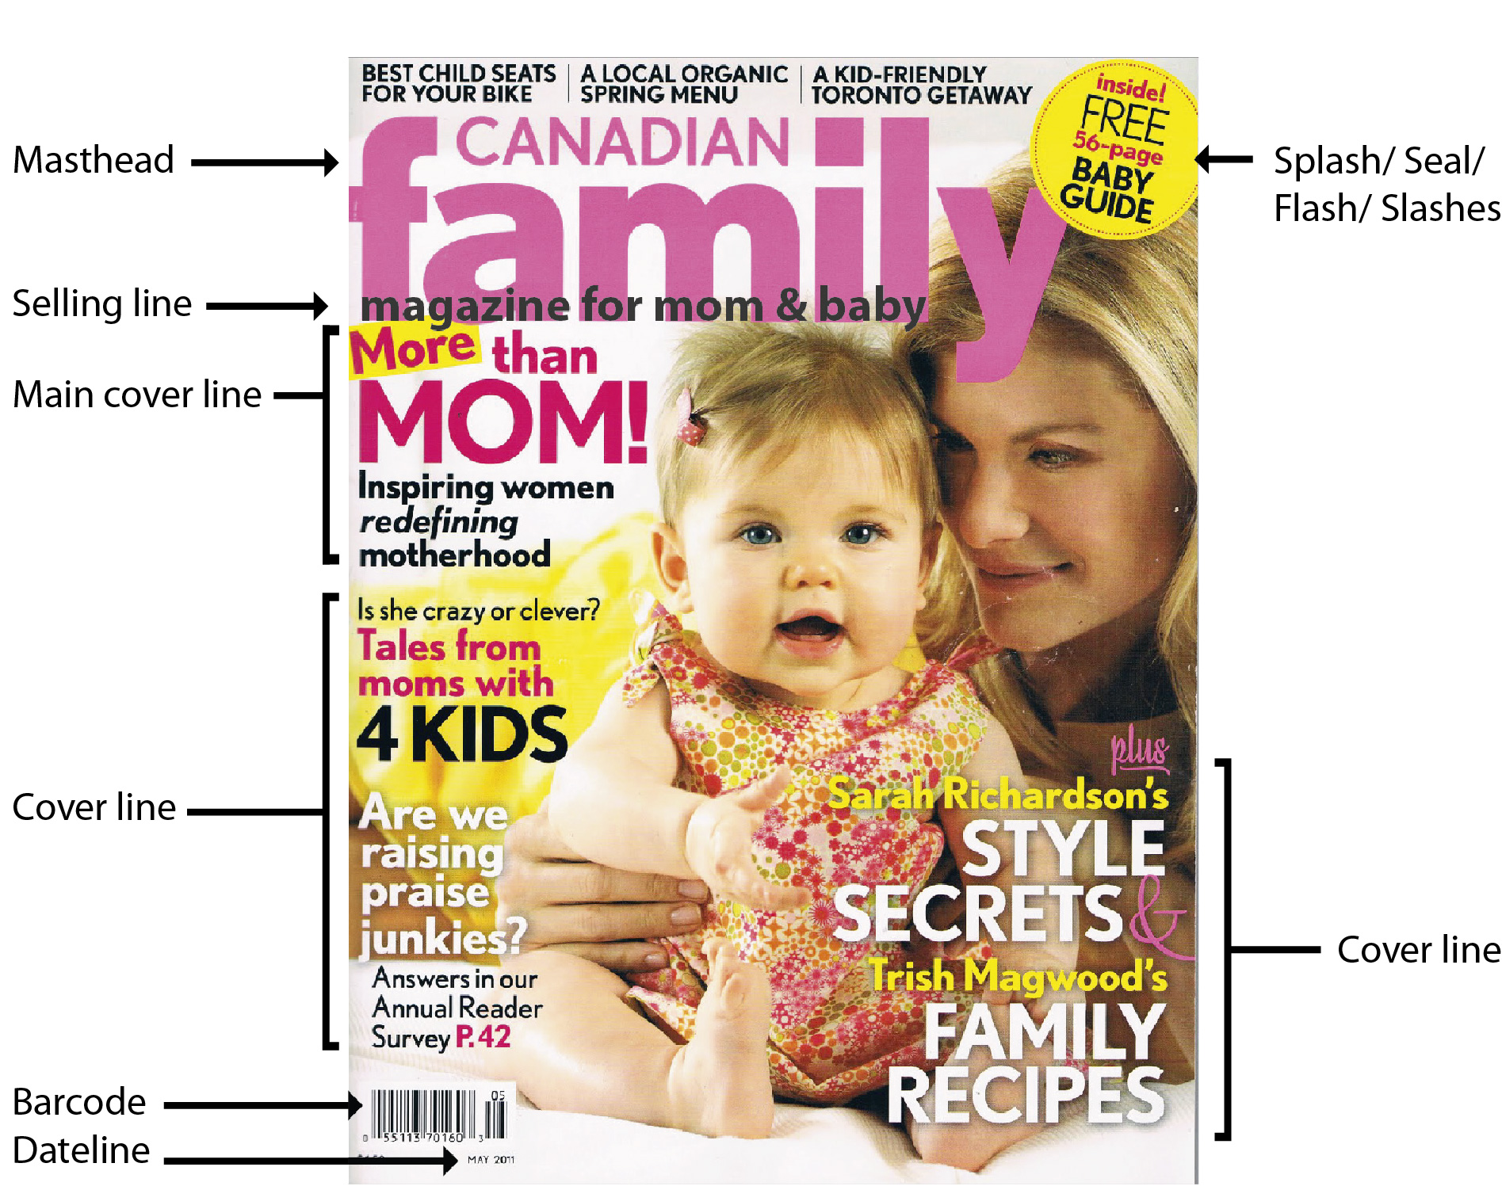

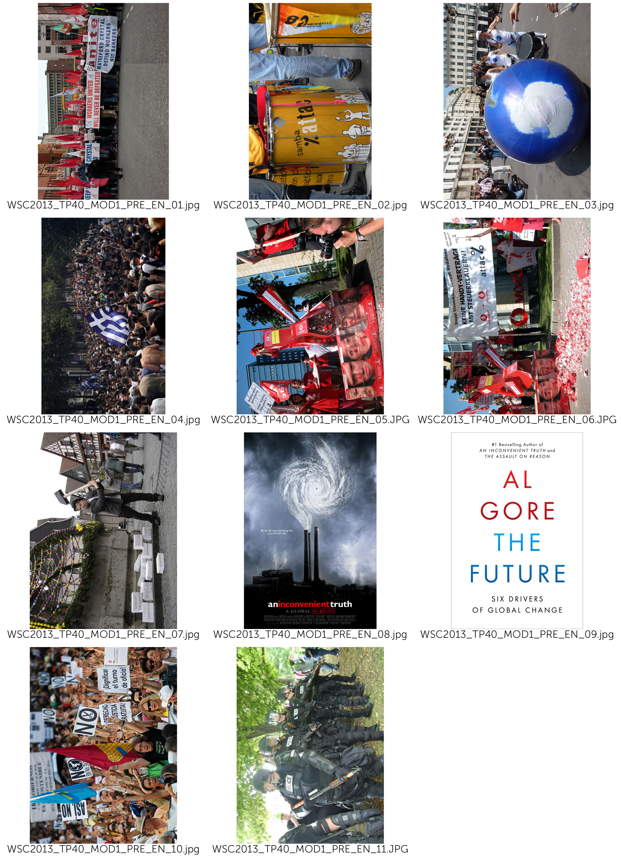
(- COVER الغلاف )
(اختر واحده من الصور التاليه:
- WSC2013_TP40_MOD1_PRE_EN_01.jpg
- WSC2013_TP40_MOD1_PRE_EN_02.jpg
- WSC2013_TP40_MOD1_PRE_EN_03.jpg)

(– Masthead الترويسه)

SPANNER in the works

(– Selling Lines )

News magazine of ATTAC network

(– Main Line Cover)

Global Tax Justice:
If everybody shares the burden, no one suffers

(– Cover Lines)

Fiscal and Economic Union
The Future by Al Gore
For a Europe-wide coordinated levy on wealth

(– Date Line)

17 August 2013

(– Splash/ Seal/ Flash/ Slashes )

SPECIAL EDITION

(– Back Cover الغلاف الخلفي )
(استخدم الصوره التاليه:
- WSC2013_TP40_MOD1_PRE_EN_07.jpg)

( Title: العنوان)

We fight for

( Main text: النص الرئيسي)
Attac sees the domination of financial markets on society as the main obstacle to the shift to a new mode of development that would be social, ecological, democratic, and relying on solidarity. In order to bring this domination to an end we demand:
• Limits to capital flow and regulations such as a tax on financial transactions so as to drastically reduce all speculative moves.
• The socialization of the banking sector so that the banks’ investment policies will be governed by social and ecological imperatives and not by short-term profits.
• The prohibition of any capital transit via tax havens to put an end to occult financial activities and to tax evasion.
• Restrictions to TNCs through international regulations.
• The cancellation of the public debt of developing countries.
• An increase in taxes on financial incomes and on private estates;
• A fair organization of international trade that is favourable to developing countries, wage earners, and the environment.
• Access to common goods of humankind (water, education, healthcare…) so that human rights are adhered to.
• Global taxes to finance access to common goods, namely taxes on TNC profits, polluting activities (carbon tax), on financial transactions, on large private estates.
• A social and ecological agriculture without GM, respectful of the principle of food sovereignty and making it possible for peasants to earn a decent living both in the North and in the South.
• Ways of solving conflicts peacefully (Attac favours non violence in its actions).
Attac also fights any extension of commodification, whether through privatization of public services, the development of pension funds, the privatization of social security, speculation on the right to pollute through a carbon market.

(– Master Pages)

SPANNER in the works

(– Page numbers رقم الصفحات)

3, 8, 9, 10, 11

(– Spine الغلاف الجانبي)

SPANNER in the works

17 August 2013

(– PAGE 3 الصفحه الثالثه )

(Title: العنوان)
Our ideas

(Main text: النص الرئيسي)
Attac is a movement opposing neo-liberal globalization
Neo-liberal globalization, based on the ‘liberalization’ of trade and financial markets, started at the end of the 1970s and has led to the total domination of financial markets on society as a whole. It is an instrument designed to further the enrichment of a tiny minority of investors at the expense of the rest of the population and the planet. Its effects are detrimental to.

Social rights

neo-liberal globalization facilitates the shipping of businesses and jobs out of the country and fosters the worldwide competition between workers and, consequently, their precarization ;
It covers up tax evasion thanks to tax havens and sets in motion the competition between national tax systems and thus the reduction of public services.

The planet

Neo-liberal globalization makes it possible for transnational companies to spread their production on the surface of the globe based solely on costs, so that the various parts of a product can be manufactured at different locations on the planet, generating thousands of miles of transport;
It sets up a competition between national environmental regulations and thus pushes them to the lowest possible level;
It tends to commercialize all aspects of society and thus extends endlessly the consumer and growth society.

North South solidarity

As it organizes tax evasion, neo-liberal globalization imposes a new form of colonialism through corruption of elites in countries of the South;
Through free trade it imposes competition between farmers in the South and the large agro-business owners of the North ;
Via the debt mechanism, it allows the World Bank and the IMF to impose massive deregulation policies on developing countries.

Democracy

WTO, IMF, World Bank and the European Union set up new global economic rules outside any democratic debate: most international negotiations on trade or financial regulation occur away from the people; Neo-liberal globalization promotes the concentration of information dissemination in the hands of a few media and internet conglomerates.
The commercialization of all spheres of society reduces people to mere consumers at the expense of their citizenship.
And so, over the past 30 years we have witnessed a substantial enrichment of capital holders to the detriment of the vast majority of wage earners, together with a continued deterioration of the condition of our planet.
In the OECD countries, the proportion of wage earners in the producing sectors has declined by 10% while the return to capital has risen since the mid-1970s. In the United States, for instance, 60% of the growth recorded since 1980 has been captured by the wealthiest 1%.

(صور المقالات : اختر واحده من الصور التاليه:
- WSC2013_TP40_MOD1_PRE_EN_03.jpg
- WSC2013_TP40_MOD1_PRE_EN_05.jpg
- WSC2013_TP40_MOD1_PRE_EN_06.jpg)

Neo-liberal globalization promotes the concentration of information dissemination.

(– Pages 8 and 9 الصفحه 9 و 8 )

(Title: العنوان)
Global Tax Justice:
If everybody shares the burden, no one suffers.

(Main text: الص الرئيسي)

How did this come about?

In the sixties and seventies capital was not very mobile, a tight net of capital transfer controls hampered the free flow of the deutschemark, schilling, pound etc. Due to this limited opportunities for capital flight taxation was reasonably fair. At this time the economy boomed, it grew faster than in the previous twenty years, full employment was close by and the differences in incomes began to shrink slowly. This scenario changed at the end of the seventies when neo-liberal politics like Thatcherism and Reaganomics got established worldwide. One of the core elements of neo-liberalism is the free flow of capital, but once capital is totally free to move it is difficult for Finance Ministers to tax it accordingly.

More and more Tax Havens

It gets even more difficult when, in the course of liberalisation, tax havens appear. You find tax havens not only in the Caribbean or Pacific (Bahamas, Samoa) but also right in the middle of Europe - Luxembourg, Liechtenstein, Monaco, Switzerland and Austria. In tax havens capitals gains and financial wealth are not only save from taxation, but the financial authorities in the countries of origin don´t get informed because of bank secrecy. The result is that the profiteers of globalisation contribute less and less to our common goods - hospitals, education, public transport, environmental protection, sport and culture.

Tax Competition Begins

Tax havens not only attract tax evaders, they also put pressure on other countries to reduce their tax rates on income, profit and wealth. In the last twenty years almost all countries have been competing in reducing taxes on income, profits, and capital gains. In the industrialised countries the average tax on business profits has dropped from 51% to 35% since 1985. Tax on interest yield from 47% to 33% and the top income tax bracket plummeted from 52% to 42%, and this process is by no means at an end. Indeed some economists consider that in the long run it won't be possible to tax profits at all. For some multinational corporations this is already the case - they file their profit tax returns in tax havens, they use tax loopholes or sometimes even manipulate their balance sheets. The result is they pay little or no tax where they are actually operating. Some examples for Austria: Creditanstalt (1998 and 99) the Spar AG (1997 and 98) and Shell Austria (1977) or the Immuno AG (1977). This is not just unfair for the community, but also for the small and midium sized businesses that can´t use these 'creative possibilities' and suffer under an unfair competitive disadvantage.

- (صور المقالات : اختر واحده من الصور التاليه:
- WSC2013_TP40_MOD1_PRE_EN_01.jpg
- WSC2013_TP40_MOD1_PRE_EN_02.jpg
- WSC2013_TP40_MOD1_PRE_EN_03.jpg)

One of the core elements of neo-liberalism is the free flow of capital.

(- INFOGRAPHIC)

(title العنوان )
Reduction of tax rates on income, profit and wealth In the industrialised countries

(text النص )
The average tax on business profits has dropped
51% to 35%

Tax on interest yield
47% to 33%

The top income tax bracket plummeted
52% to 42%

(caption for infographic اسم الصوره )
Since 1985

( -TABLE الجدول )

(title العنوان )
The multinational corporations who pay little or no tax

(text النص )
Company Year
Creditanstalt 1998,1999
Spar AG 1997, 1998
Shell Austria 1977
Immuno AG 1977

(caption for table اسم الجدول )
Some examples for Austria

(– Pages 10 and 11الصفحه 10 و 11 )

(Title: العنوان )

The Future by Al Gore – review.

(Main text: النص الرئيسي )

Al Gore's alarming new guide to what needs to change in world politics is essential reading
According to reliable reports, the new leadership in Beijing has been reading Alexis de Tocqueville. It's not hard to see why China's elite might look for guidance to the aristocratic French thinker. In his classic text The Ancien Regime and the Revolution (1856), de Tocqueville wrote that the danger of revolution is not greatest in the depths of poverty and despair but when conditions have been improving – especially if some are benefiting far more than others. The relevance of this for China is obvious. The implications for policy are rather less so, since de Tocqueville also warned that for a bad government, the moment of greatest danger comes when it starts to reform. In such circumstances, repression might be a more prudent course of action. This troubling ambiguity could explain why Chinese readers, struggling to decipher the intentions of their rulers, made de Tocqueville's book a national bestseller.
From a parochial British perspective, what might be most significant is the fact that China's rulers are reading de Tocqueville at all. It is difficult to imagine David Cameron devoting any time to a 19th-century thinker. Along with much of the political class, the prime minister seems resistant to the notion that history has anything to teach, and looks for guidance to writers who extol the wisdom of crowds, explain the momentous importance of tipping points or pass on the revelation that humans are social animals – the fleeting nostrums of the airport bookstore. But if our rulers will not read the classics then they must read Al Gore, who, after eight years of reading and thinking, has produced a guide for the politically perplexed that will surely endure.

- (صور المقالات : اختر واحده من الصور التاليه:
- WSC2013_TP40_MOD1_PRE_EN_08.jpg
- WSC2013_TP40_MOD1_PRE_EN_09.jpg)

The Cover of Al Gore’s Book, The future

(Title: العنوان)

For a Europe-wide coordinated levy on wealth

(Main text: النص الرئيسي)

The nature of the crisis
A constantly increasing disparity of wealth is an intrinsic aspect of capitalism. Wealth grows faster than workers’ income. Large amounts of wealth grow faster than small amount. In some countries, wealth taxes exist. But the tax rates are much lower than the growth rates of large fortunes. Therefore, strong political correctives to create a fairer distribution are necessary. This applies even more in the currently dominant form of capitalism driven by financial markets, since here the disparity in the distribution of prosperity has been growing especially rapidly. As this polarization of the distribution of wealth grows, so does the amount of capital circulating around the world in search of profitable investment opportunities. In particular since the 1970s, this mass has increased dramatically. It became less and less possible to exploit this capital profitably in the productive economy. In the search for new sources of profit, the international financial markets became more and more important. This transition was accompanied and fostered by constantly increasing deregulation and globalization of the financial markets, and led to a quite novel dynamism involving the polarization of the distribution of income and assets. The increasing dominance of the financial markets has allowed gigantic profits – and also losses – to be made within seconds. Thus the system is becoming more and more unstable. More and more speculative bubbles develop, which must burst sooner or later.

- (صور المقالات : اختر واحده من الصور التاليه:
- WSC2013_TP40_MOD1_PRE_EN_10.jpg
- WSC2013_TP40_MOD1_PRE_EN_11.jpg)

A constantly increasing disparity of wealth is an intrinsic aspect of capitalism

(Title: العنوان )

Fiscal and Economic Union

(Main text: النص الرئيسي )

Fiscal pact, ESM, six-pack, two-pack
Under the pressure of the crisis, the powerful are pushing through their murky "reform" measures at a rapid pace. The logic is always the same: Reduce debts through cuts in social services and privatisation, raise competitiveness through wage cuts and eliminate workers rights. The consequences: A deep recession, further aggravating the economic crisis. In southern Europe the 'Troika' of the ECB, EU Commission, and the IMF dictate one so called Memorandum (austerity package) after another. The reality is a devastating social crisis. Mass unemployment, poverty, homelessness, soaring crime and waves of suicides are once again part of European everyday life. And "coincidentally" our democracies are being hollowed out: highly indebted countries are forced to transfer their sovereignty from their elected parliaments to the EU. Every day, the technocrats of the EU Commission and the ECB gain yet more power for themselves.
Can things get even worse, after all the reform packages so far that have established a neo-liberal, anti-democratic politics throughout Europe? Yes they can. In the European Council the introduction of a fiscal and economic union is being prepared right now. The diktat of austerity, through which Greece, Spain and Portugal suffer right now, will be institutionalised on the European level. Or as the European Commission President Barroso put it: A quiet revolution has been taking place.

- (صور المقالات : استخدم الصورة التاليه:
- WSC2013_TP40_MOD1_PRE_EN_04.jpg)

In the European Council the introduction of a fiscal and economic union is being prepared.

